



TABLE OF CONTENTS

**0. Table of Contents** Pages 1-2

**1. System Overview**

⮚ Overview Page 3

⮚ User Manual Contents Page 4

⮚ Detailed File Descriptions Page 5

2. System Requirements and Login

⮚ System Requirements Page 6

⮚ System Login Page 6

3. Detailed Screen Functionality

⮚ Home Page Page 7

⮚ Narrative Description of Home Page Page 8

⮚ Step-by-Step Instructions for Home Page Page 8

⮚ Order Details Page 9

⮚ Narrative Description of Order Details Page 10

⮚ Step-by-Step Instructions for Order Details Page 10

⮚ Order Summary Page 11

⮚ Narrative Description of Order Summary Page 12

⮚ Step-by-Step Instructions for Order Summary Page 12

⮚ Order Confirmation Page 13

⮚ Narrative Description of Order Confirmation Page 14

⮚ Step-by-Step Instructions for Order Confirmation Page 14

⮚ Error Page Page 15

⮚ Narrative Description of Error Page Page 16

⮚ Step-by-Step Instructions for Error Page Page 16

⮚ Admin Directory Page 17

⮚ Narrative Description of Admin Directory Page 18

⮚ Step-by-Step Instructions for Admin Directory Page 18

⮚ Admin - Reports Page 19

⮚ Narrative Description of Admin - Reports Page 20

⮚ Step-by-Step Instructions for Admin - Reports Page 20

⮚ Admin – Add Customer Page 21

⮚ Narrative Description of Admin – Add Customer Page 22

⮚ Step-by-Step Instructions for Admin – Add Customer Page 22

⮚ Admin – Remove Customer Page 23

⮚ Narrative Description of Admin – Remove Customer Page 24

⮚ Step-by-Step Instructions for Admin – Remove Customer Page 24

4. Table Descriptions

⮚ Customer Table Page 25

⮚ Reports Table Page 26

⮚ Waiting List Table Page 27

⮚ Orders Deal Table Page 28

5. Background Information

⮚ List of Group Meetings Conducted and Individual Work Page 29

SYSTEM OVERVIEW

Overview

ABC Solutions has now successfully implemented a website for Easy Insure. With the customer successfully choosing a life insurance policy, a report is generated to all locations of the Easy Insure company. With the administrators having their own portal within the website, they’re able to see and confirm (or deny) all customers. Reports showcase the life insurance type and the monthly premium. The regional manager’s focus is the expansion to other countries, which insurance type is the top seller, and continued training for all employees in all areas within the company..

The User Manual contains all essential information for the user to make full use of the Easy Insure Website. This manual includes a description of the system login and requirements, screen functionality, table descriptions, and background information.

SYSTEM OVERVIEW

User Manual Contents

**Detailed File Descriptions:** This section includes a brief summary of the files that will be used to run the website.

**Detailed Web-Page Layouts:** Each Web-Page has been screen-shot and recorded in the User Manual. This acts as a visual aid for the Narrative Description and step-by-step instructions for each web-page and function.

**Narrative Description:** Each Web-Page has a Narrative Description that explains the layout, functionality, and order of operations.

**Step-By-Step Instructions:** Each Web-Page has Step-By-Step Instructions available so that Admin’s and Visitors to the website can learn how to properly traverse the website.

**Table Descriptions:** All logic inside of the php tables are documented.

**Background Information**: This section documents the work completed.

SYSTEM OVERVIEW

Detailed File Descriptions

A list of the files for Easy Insure’s Website

**Description File**

**I. Home Page** easy_insure_home.php

**II. Active Directory**

* **Generate Order Report** easy_insure_wait_list.php
* **Add Customer** easy_insure_add_customer.php
* **Remove Customer** easy_insure_remove_customer.php
* **Return User to Homepage** easy_insure_home.php

**III. Order Details**

* **Generate Summary at** easy_insure_report.php

**All Locations**

* **Generate Order Confirmation** easy_insure_order_confirmed.php
* **Return User to Homepage** easy_insure_home.php

**IV. Error Page** easy_insure_database_error.php error.php SYSTEM REQUIREMENTS AND LOGIN

**SYSTEM REQUIREMENTS**

**Operating System**: Windows 7 or higher; Sierra (10.12) or Higher

**Processor:** Core i3 or equivalent and higher

**Memory:** 4gb

**Network**: Broadband Internet Connection

**SYSTEM LOGIN**

On the Homepage, Easy Insure administrative users can select Login and can then type in the word ‘Admin’ to gain access to the website’s Admin Directory. This is found on the bottom right of the header on the home page.

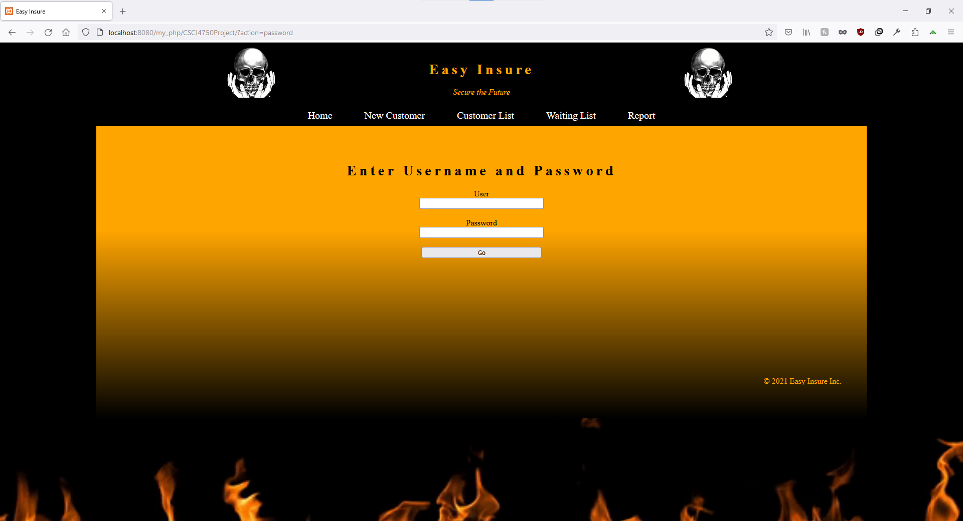

DETAILED SCREEN FUNCTIONALITY

HOMEPAGE



DETAILED SCREEN FUNCTIONALITY

**Narrative Description of Home Page**

As requested, the home page has term, whole, and universal life insurance displayed at the center of the page for easy access and design emphasis. It is positioned in the body to draw attention to the three life insurance options. This information will be called from the easy_insure_home.php file. The header of the webpage, you are welcomed by a navigation bar with five options to click: “Home”, “New Customer”, “Customer List”, “Waiting List”, and “Report” and asks the customer to learn about term, whole, and universal life insurance. When a customer selects a particular insurance, he/she will be taken to the ‘Order Details’ page where he/she can begin filling out his/her details.

**Step-by-Step Instructions of Home Page**

**Example:**

1. The landing page is an explanation of the different services offered.
2. An employee can use the information as a reference when communicating policies to a customer or potential customer.
3. There is a navigation bar at the top of the home page that can be used to navigate to any other page in the directory, though you will typically go to the New Customer or Waiting List pages to add a customer or to set up a future appointment or even to access current customer data through the customer list.

DETAILED SCREEN FUNCTIONALITY

Customer Details

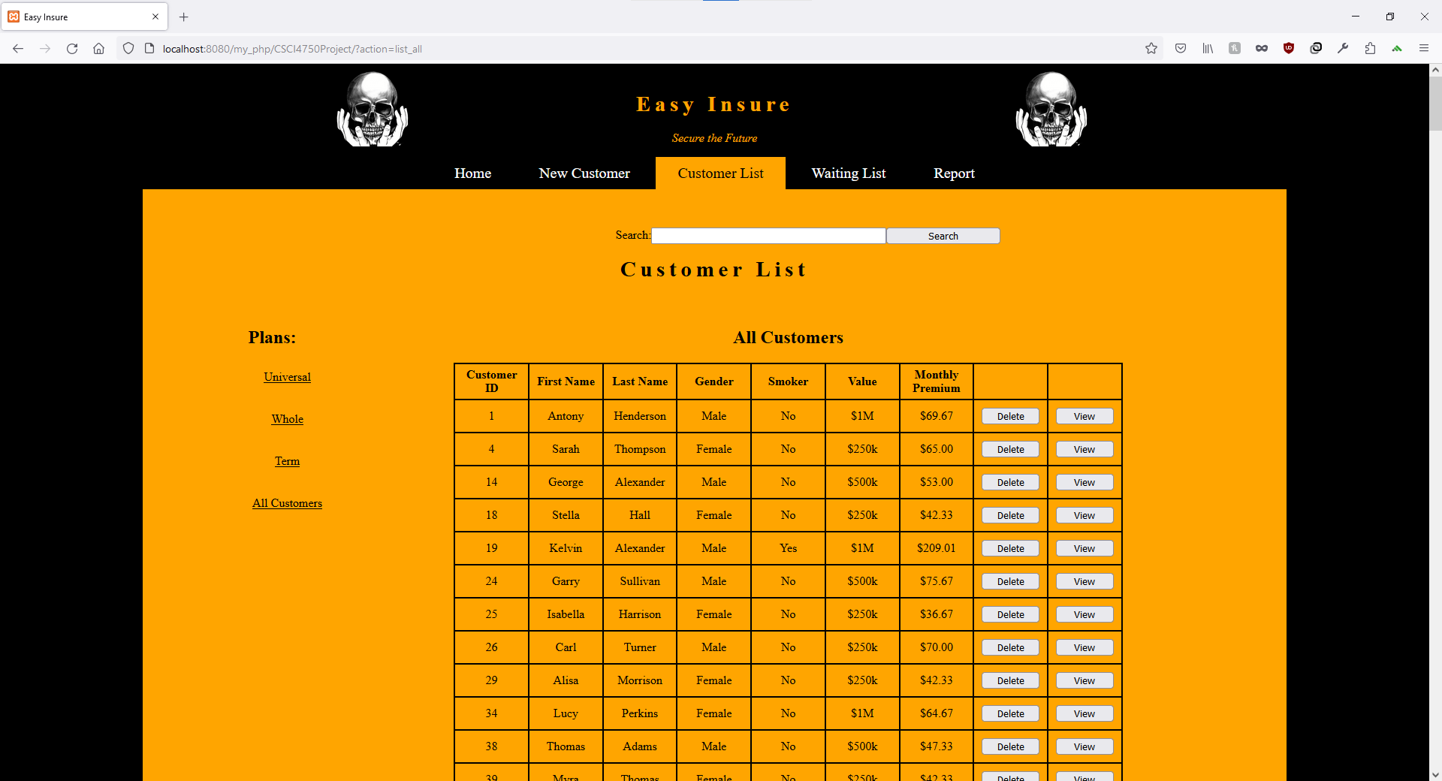

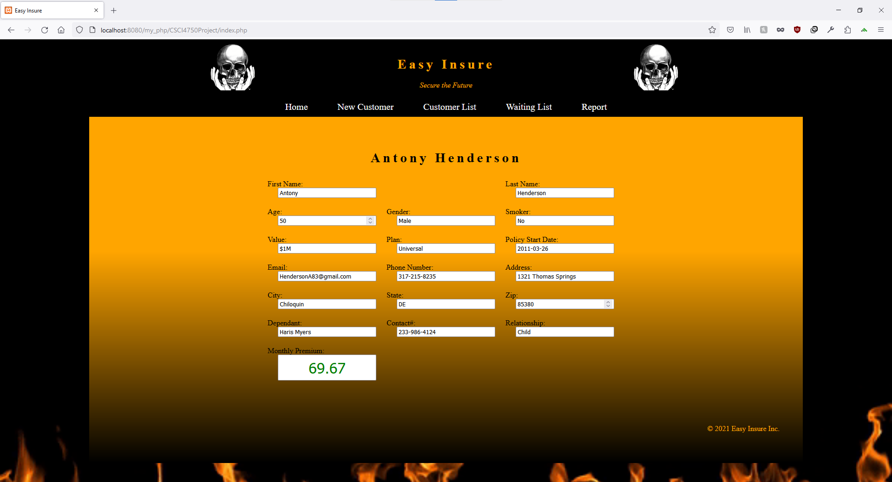DETAILED SCREEN FUNCTIONALITY

Narrative Description of Customer Details

The Customer details page is accessed through the easy_insure_customer_list.php. The Customer details page is accessed after the client has been added to the database as a customer. The representative will search for the customer from the customers list page and then click on the corresponding view button to see the full customer information.

**Step-by-Step Instructions of Customer Details**

1. Click on the Customer List in the navigation bar between the header and the body of the home page.
2. Search for the customer using the search bar at the top of the page.
3. Click on the View Button in the rightmost column of the desired customer listing.

DETAILED SCREEN FUNCTIONALITY

Waiting List

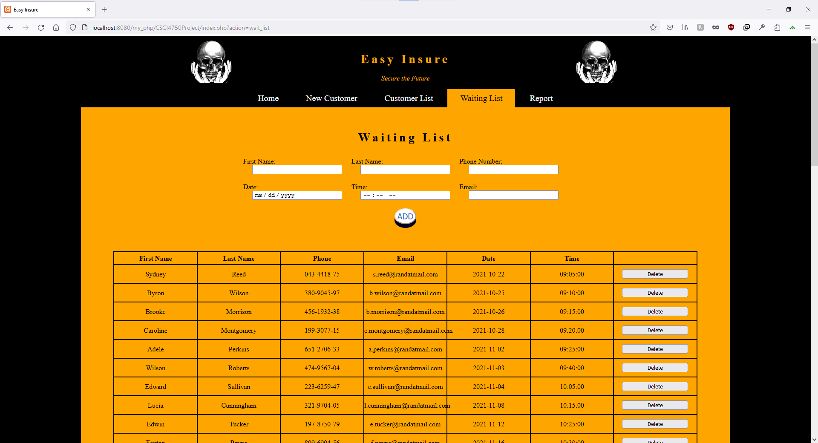

Narrative Description of Waiting List

The waiting list, that is contained in the file easy_insure_wait_list.php, can be accessed by all locations and all staff. However, the main people that would be using the waiting list would be the front desk. Here the clerk can fill out the following fields: First Name, Last Name, Phone Number, Date, Time, and Email. The date is formatted with mm/dd/yyyy and time is formatted with hours, minutes, and seconds. The waiting list is in ascending order by time. This allows for first in first out.

**Step by Step Description of Waiting List**

The waiting list consists of new customers that have signed up for insurance coverage in the system and are awaiting processing. The list is time stamped and ordered according to date of entry. The values that were entered by the customer are awaiting review from the responsible agent to assess the amount of Monthly Premiums that the customer will be charged for the insurance package.

Step by Step:

1. Information is entered by the customer
2. Values are then calculated by the system
3. An agent reviews the calculated values
4. The customer is given the quote for their coverage Monthly Premiums

DETAILED SCREEN FUNCTIONALITY

Order Confirmation

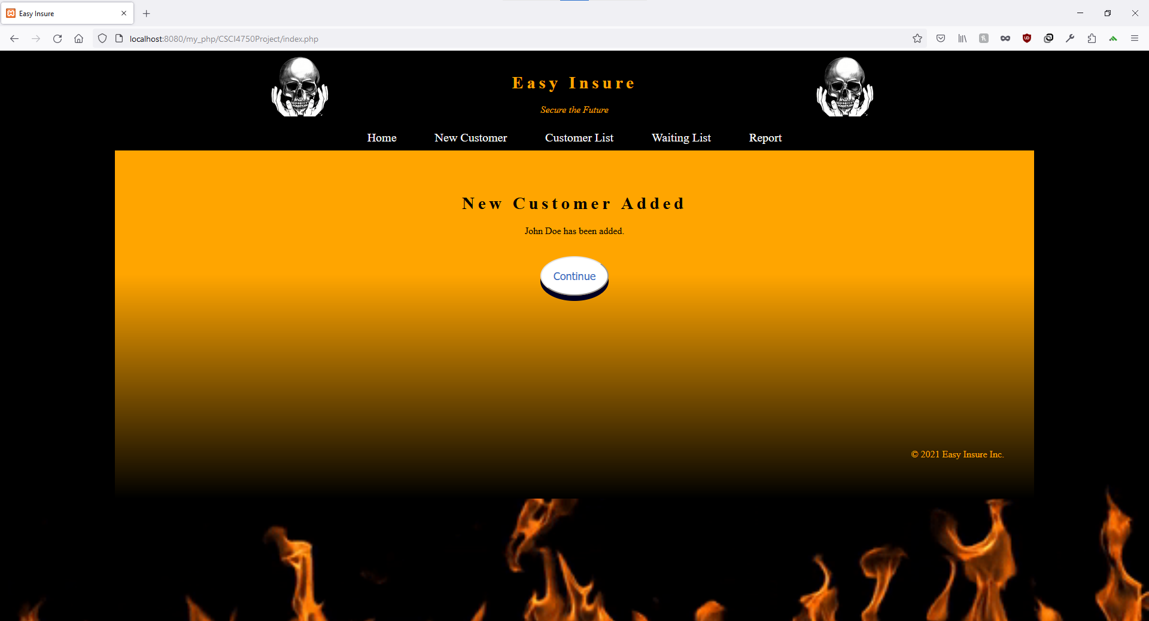

Narrative Description of Order Confirmation

Used to verify that the customer information has been successfully added to the database.

**Step-by-Step Instructions of Order Confirmation**

From this screen you can click on continue to be taken to the customer list page where you can also search for the customer added and verify that all the information was added correctly.

DETAILED SCREEN FUNCTIONALITY

Error Page

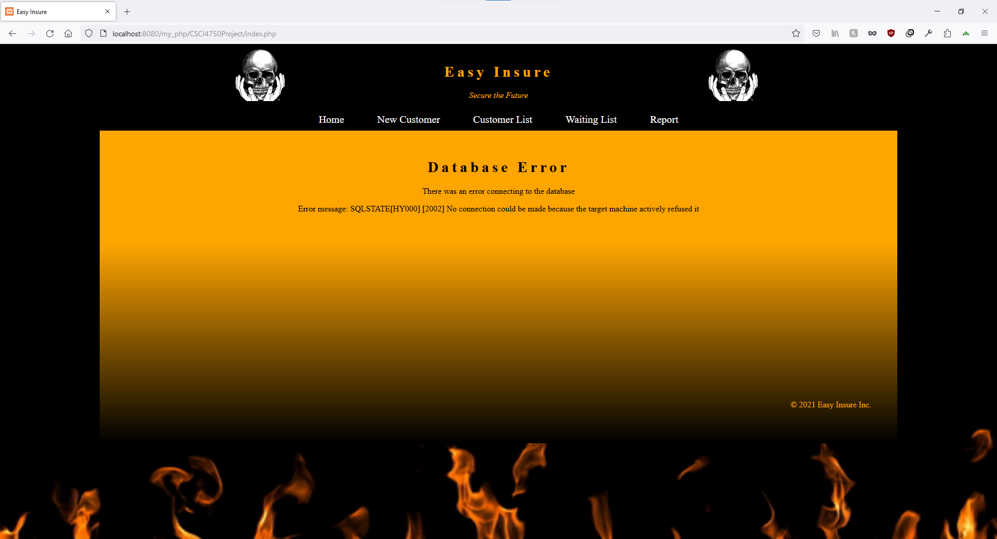

Narrative Description of Error Page

This page will be displayed if there is an error in connecting to the SQL database.

**Step-by-Step Instructions of Error Page**

Make sure the SQL database is functional and your password information is correct. You may need to contact technical support.

DETAILED SCREEN FUNCTIONALITY

Admin – Directory

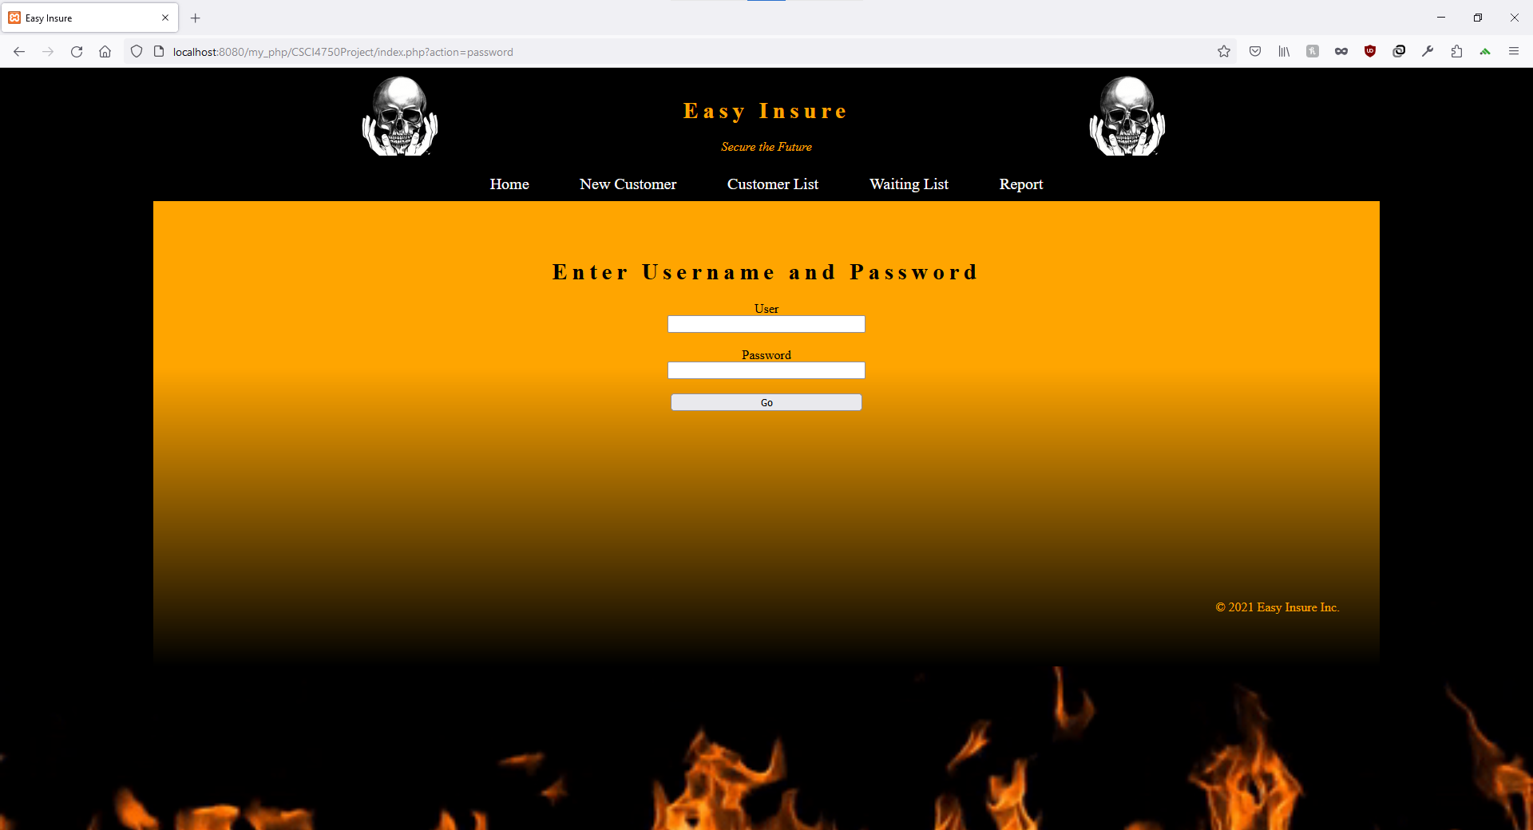

Narrative Description of Admin – Directory

This will be the login to get access to the regional manager report.

**Step-by-Step Instructions of Admin - Director**

Validate your identity with your administrator username and password.

DETAILED SCREEN FUNCTIONALITY

Admin - Reports

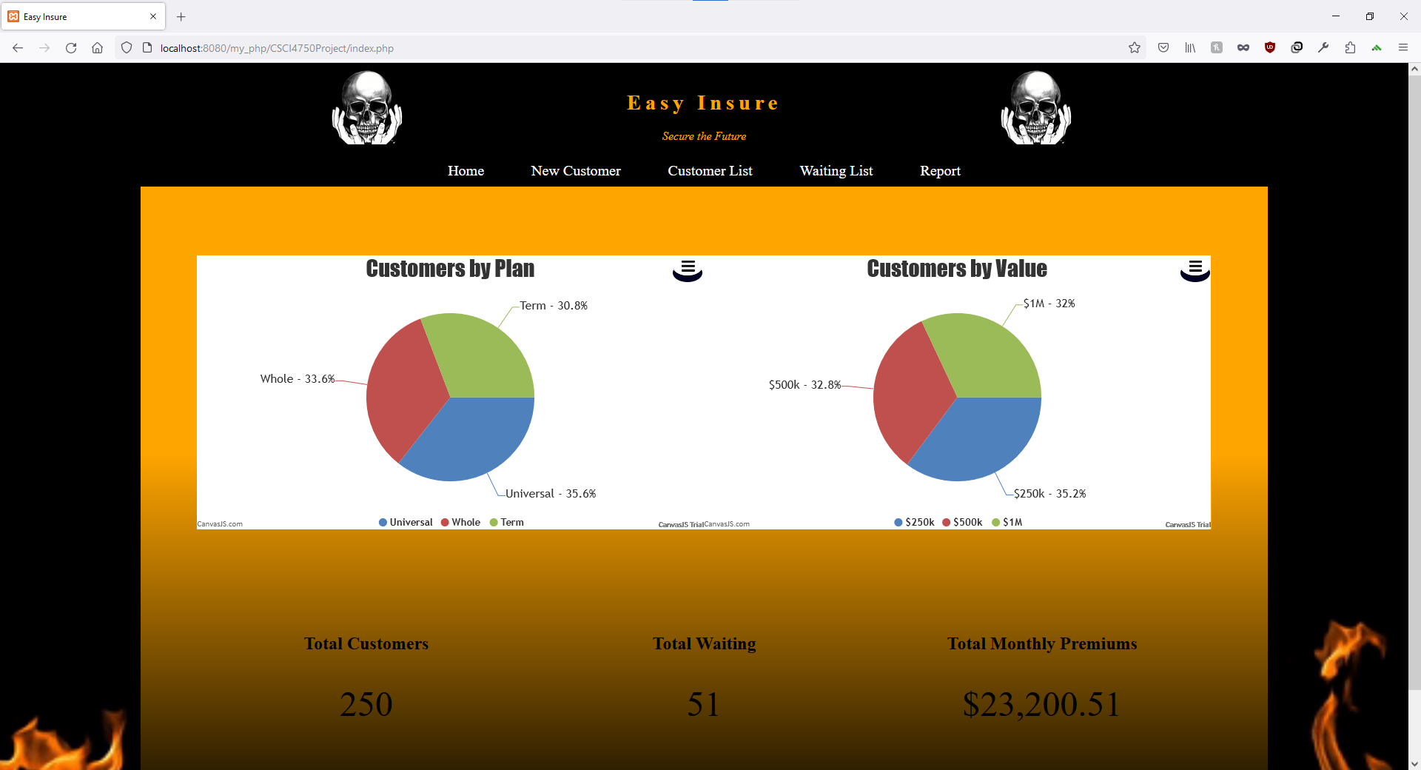

Narrative Description of Admin - Reports

The Admin Reports page will be populated with the current calculated results of the database’s directory. The reports will be broken up into relevant categories used for marketing and audit purposes.

**Step-by-Step Instructions of Admin - Reports**

When the Admin Reports page is triggered it will populate the area with the collected data:

* Customers by Plan: The number of customers enrolled in each plan category.
* Customers by Value: The percentage of customers falling within specific coverage amount ranges.
* Total Customers: The total number of all current customers in the directory.
* Total Waiting: The total number of new customers that are on the waiting list to be reviewed by agents.
* Total Monthly Premiums: This is the total dollar amount associated with the current plans active with customers.

DETAILED SCREEN FUNCTIONALITY

Admin – Add Customer

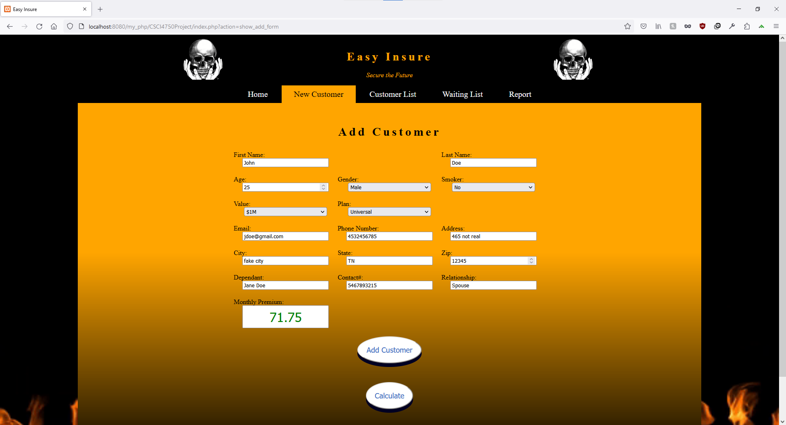

Narrative Description of Admin – Add Product

This is the place an employee can add a new customer to the database. You will need to fill out the form completely in order to provide a quote as well.

**Step-by-Step Instructions of Admin – Add Product**

1. Click the text box corresponding to “ID (Usually last 4 numbers of the customer’s social security number” to acknowledge you will be listed in Easy Insurers database.

2. Click the text box corresponding to “First Name” to input the first name.

3. Click the text box corresponding to “Last Name” to input last name.

4. Click the text box corresponding to “Gender” to input his/her gender.

5. Click the text box corresponding to “Smoker to input if the customer is a smoker or not.

* The “Value” text box is determined through an algorithm embedded within the php code. It is called when the “smoker text box” has been checked. This will tell the system to calculate for the appropriate rate.
* The “Monthly Premium” is calculated with the results of the entered fields values
* The “Delete text box” is an option for the regional administrator to delete customer for various reasons. Examples: Death, No longer paying monthly premium, etc…

DETAILED SCREEN FUNCTIONALITY

Admin – Remove Customer

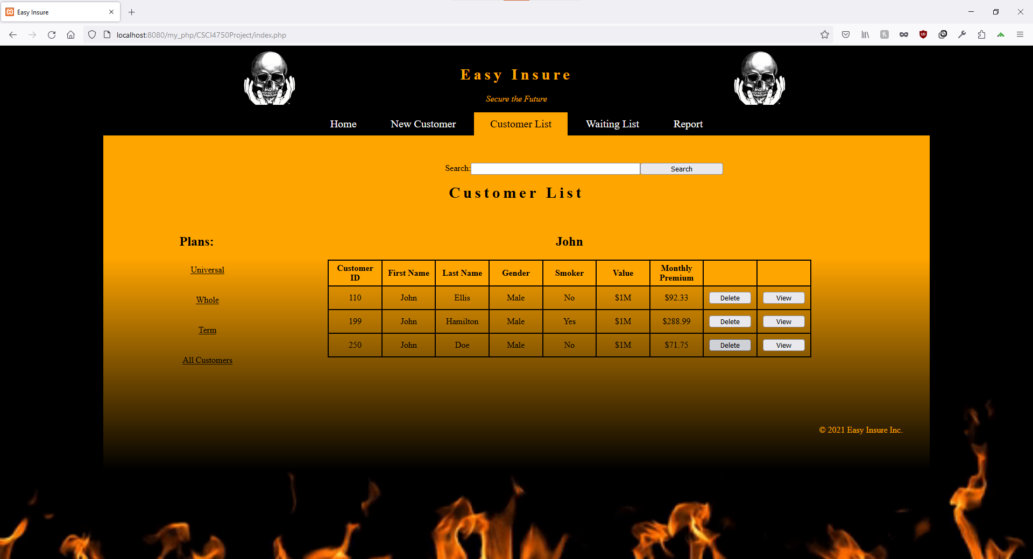

Narrative Description of Admin – Remove Product

You can remove customers from the Customer List page as well.

**Step-by-Step Instructions of Admin – Remove Product**

  Simply search for the desired customer and click the delete button on the right of the table.

TABLE DESCRIPTIONS

Customer Table – Structure

Example

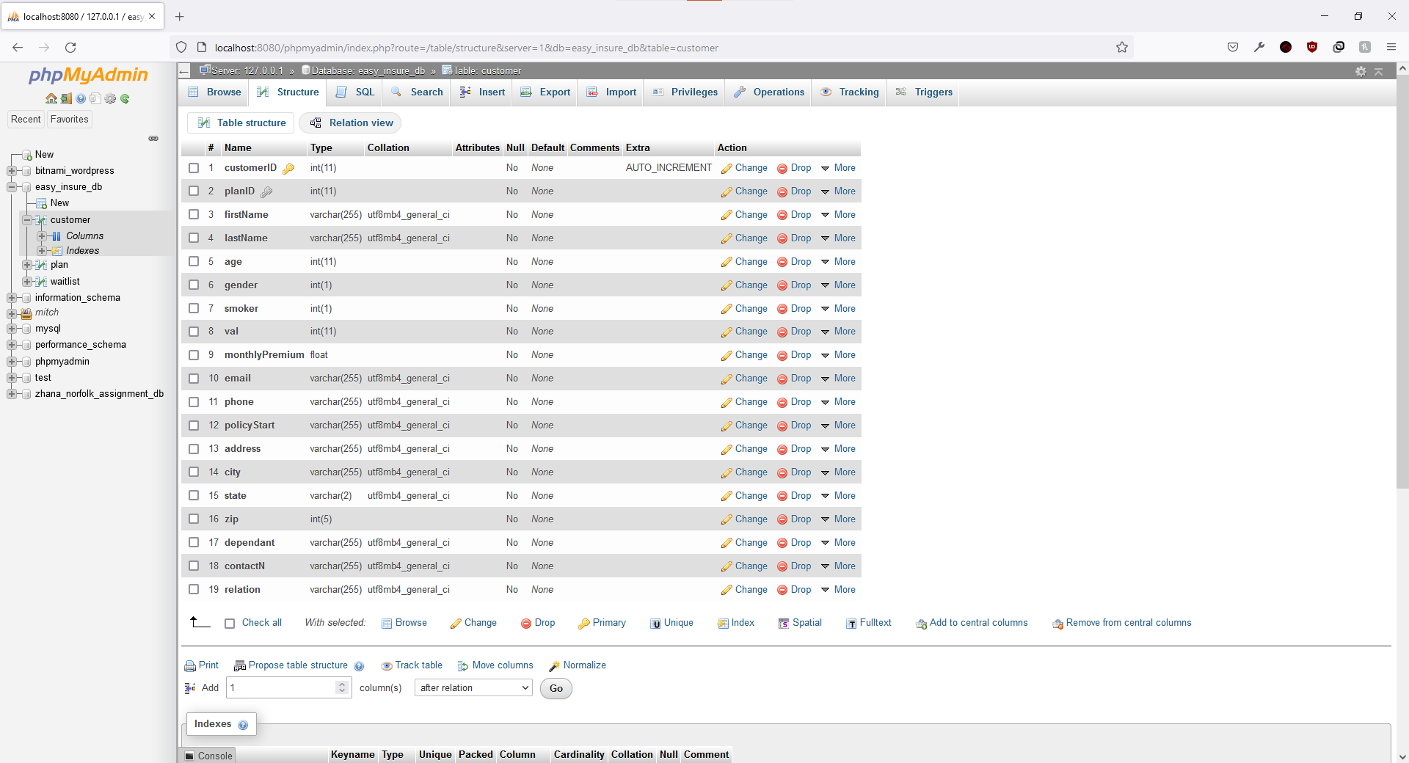

Customer Table – Contents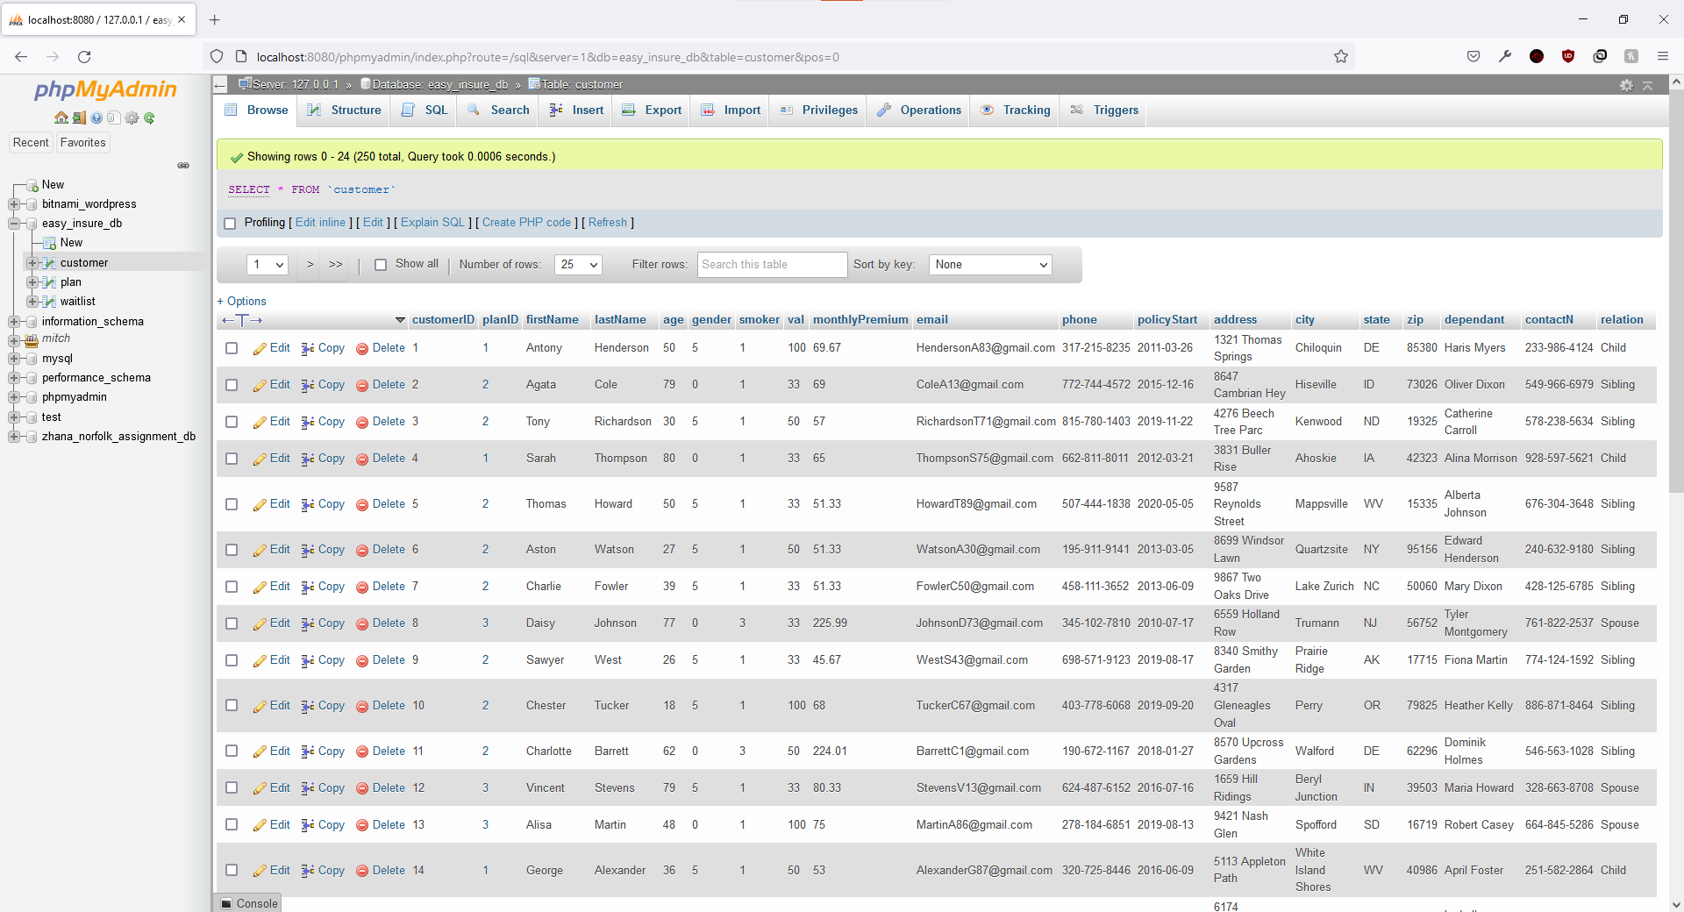

Example

Customer Table – Narrative Description

Each entry on the customer table is unique to that user. The values that are entered transfer the customer to their filtered category that helps to calculate their premiums based on their information.

The Customer Table is composed of the following values:

· customerID(PK)- An assigned number which is the Primary Key associated with the customer

· planID – The number assigned to the customer’s plan

· firstname – The customer’s first name

· lastName - The customer’s last name

· age – The age of the customer

· gender – The customer’s gender

· smoker – Value based on whether yes or no was selected on smoking

The remaining values include ‘monthlyPremium’, ‘email’, ‘phone’, ‘policyStart’, ‘address’, ‘city’, ‘state’, ‘zip’, ‘dependent’, ‘contactN’, and ‘relation’

TABLE DESCRIPTIONS

Waiting List Table – Structure

Example:

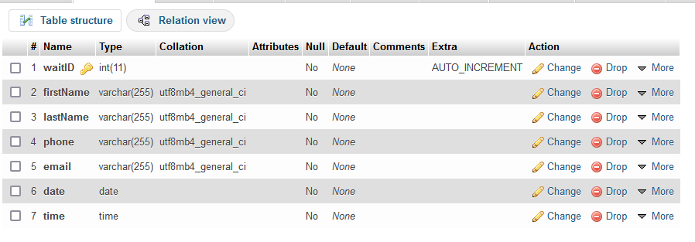

Waiting List Table – Contents

Example:

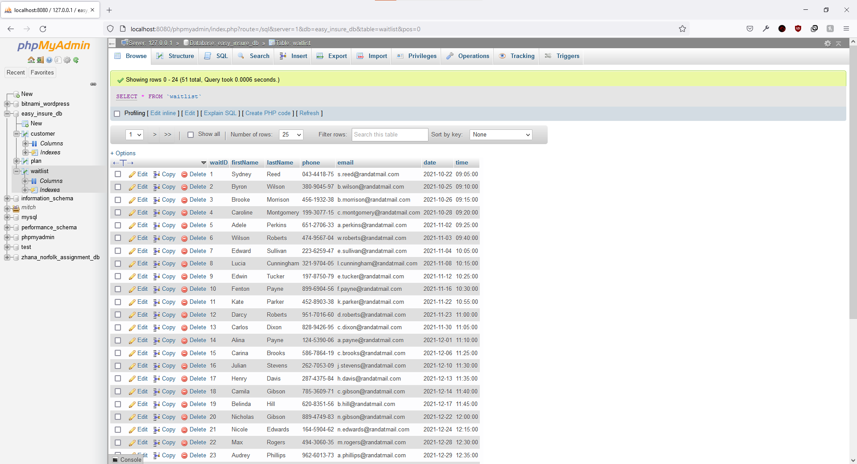

Waiting List Table – Narrative

The Waiting List consists of the total number of new customers that are on the waiting list to be reviewed by agents

The Waiting List Table is composed of the following values:

· waitID(PK)- An assigned number which is the Primary Key associated with the customer

· firstname – The customer’s first name

· lastName - The customer’s last name

· phone – The customers phone number

· email – The customer’s email account

· date – The date the customer was entered into the waiting list

· time – The timestamp of the waiting list entry

BACKGROUND INFORMATION

List of Group Meetings Conducted and Individual Work

DATE SUBJECT NOTES

10/30/2021 Individual Work **Kirk Paitsel**

11/5/2021 Individual Work **Johnny Baker**

11/7/2021Individual Work **Nicholas Fox**

11/9/2021 Individual Work **Jacob Allen**

11/14/2021 Group meeting

11/16/2021 Individual Work **Johnny Baker**

11/17/2021 Individual Work **Mitch Bishop**

11/18/2021 Individual Work **Johnny Baker**

11/19/2021 Individual Work **Nicholas Fox**

11/20/2021 Individual Work **Nicholas Fox**